**­­NAME: R S Madhavan**

**REG NO: 19BCE7029**

**LAB: CSE4002 Mobile Application Development LAB**

1. Design an App Activity that finds the distance between Guntur to Chennai. When the chip buttons car is clicked then the time 7hrs should display in the textfield1, when bike is clicked 9hrs should display in second text field, when train chip button is presses 6hrs should display and when run chip button is presses then 40hrs should display in fourth text filed. When the arrow button is clicked, the edit Text should be swapped.

MainActivity.java

package com.example.maddymaps;  
  
import androidx.appcompat.app.AppCompatActivity;  
  
import android.annotation.SuppressLint;  
import android.os.Bundle;  
import android.view.View;  
import android.widget.EditText;  
import android.widget.ImageButton;  
import android.widget.Toast;  
  
import com.google.android.material.chip.Chip;  
import com.google.android.material.chip.ChipGroup;  
  
public class MainActivity extends AppCompatActivity {  
 EditText start,end,car,bike,train,walk;  
 ImageButton reverse;  
 @Override  
 protected void onCreate(Bundle savedInstanceState) {  
 super.onCreate(savedInstanceState);  
 setContentView(R.layout.*activity_main*);  
 start = findViewById(R.id.*editTextTextPersonName*);  
 end = findViewById(R.id.*editTextTextPersonName2*);  
 car = findViewById(R.id.*editTextTextPersonName3*);  
 bike = findViewById(R.id.*editTextTextPersonName4*);  
 train = findViewById(R.id.*editTextTextPersonName5*);  
 walk = findViewById(R.id.*editTextTextPersonName6*);  
 reverse = findViewById(R.id.*imageButton*);  
 ChipGroup chipGroup = findViewById(R.id.*chipGroup*);  
  
 chipGroup.setOnCheckedChangeListener(new ChipGroup.OnCheckedChangeListener() {  
 @SuppressLint("SetTextI18n")  
 @Override  
 public void onCheckedChanged(ChipGroup chipGroup, int i) {  
 car.setText("");bike.setText("");train.setText("");walk.setText("");  
 Chip chip = chipGroup.findViewById(i);  
 if (chip != null) {  
 switch(i){  
 case 1: car.setText("7 hrs");  
 break;  
 case 2: bike.setText("9 hrs");  
 break;  
 case 3: train.setText("6 hrs");  
 break;  
 case 4: walk.setText("40 hrs");  
 break;  
 }  
 }  
 }  
  
 });  
  
 reverse.setOnClickListener(new View.OnClickListener() {  
 @Override  
 public void onClick(View v) {  
 String temp = start.getText().toString();  
 String temp1 = end.getText().toString();  
 if(!temp.isEmpty() && !temp1.isEmpty()){  
 start.setText(temp1);  
 end.setText(temp);  
 }  
 else{  
 Toast.*makeText*(getApplicationContext(), "Enter start and end point", Toast.*LENGTH_SHORT*).show();  
 }  
 }  
 });  
 }  
}

Activity_main.xml

<?xml version="1.0" encoding="utf-8"?>  
<androidx.constraintlayout.widget.ConstraintLayout xmlns:android="http://schemas.android.com/apk/res/android"  
 xmlns:app="http://schemas.android.com/apk/res-auto"  
 xmlns:tools="http://schemas.android.com/tools"  
 android:layout_width="match_parent"  
 android:layout_height="match_parent"  
 android:orientation="vertical"  
 tools:context=".MainActivity">  
  
 <com.google.android.material.chip.ChipGroup  
 android:id="@+id/chipGroup"  
 android:layout_width="337dp"  
 android:layout_height="45dp"  
 android:layout_marginTop="20dp"  
 app:layout_constraintEnd_toEndOf="parent"  
 app:layout_constraintHorizontal_bias="0.531"  
 app:layout_constraintStart_toStartOf="parent"  
 app:layout_constraintTop_toBottomOf="@+id/editTextTextPersonName2"  
 app:singleSelection="true">  
  
 <com.google.android.material.chip.Chip  
 style="@style/Widget.MaterialComponents.Chip.Choice"  
 android:layout_width="78dp"  
 android:layout_height="wrap_content"  
 android:checkable="true"  
 android:textAllCaps="false"  
 app:checkedIconVisible="true"  
 app:chipIcon="@drawable/car"  
 app:chipIconVisible="true"  
 app:closeIconVisible="false" />  
  
 <com.google.android.material.chip.Chip  
 style="@style/Widget.MaterialComponents.Chip.Choice"  
 android:layout_width="78dp"  
 android:layout_height="wrap_content"  
 android:checkable="true"  
 app:chipIcon="@drawable/bike"  
 app:chipIconVisible="true" />  
  
 <com.google.android.material.chip.Chip  
 style="@style/Widget.MaterialComponents.Chip.Choice"  
 android:layout_width="78dp"  
 android:layout_height="wrap_content"  
 android:checkable="true"  
 app:chipIcon="@drawable/train"  
 app:chipIconVisible="true" />  
  
 <com.google.android.material.chip.Chip  
 style="@style/Widget.MaterialComponents.Chip.Choice"  
 android:layout_width="78dp"  
 android:layout_height="wrap_content"  
 android:checkable="true"  
 app:chipIcon="@drawable/walk"  
 app:chipIconVisible="true" />  
  
 </com.google.android.material.chip.ChipGroup>  
  
 <ImageView  
 android:id="@+id/imageView1"  
 android:layout_width="32dp"  
 android:layout_height="32dp"  
 android:layout_marginStart="48dp"  
 android:layout_marginLeft="48dp"  
 android:layout_marginTop="28dp"  
 app:layout_constraintStart_toStartOf="parent"  
 app:layout_constraintTop_toTopOf="parent"  
 app:srcCompat="@drawable/gps" />  
  
 <ImageView  
 android:id="@+id/imageView2"  
 android:layout_width="wrap_content"  
 android:layout_height="wrap_content"  
 android:layout_marginTop="30dp"  
 app:layout_constraintStart_toStartOf="@+id/imageView1"  
 app:layout_constraintTop_toBottomOf="@+id/imageView1"  
 app:srcCompat="@drawable/location" />  
  
 <EditText  
 android:id="@+id/editTextTextPersonName"  
 android:layout_width="wrap_content"  
 android:layout_height="wrap_content"  
 android:layout_marginStart="12dp"  
 android:layout_marginLeft="12dp"  
 android:ems="10"  
 android:hint="STARTING POINT"  
 android:inputType="textPersonName"  
 app:layout_constraintStart_toEndOf="@+id/imageView1"  
 app:layout_constraintTop_toTopOf="@+id/imageView1" />  
  
 <EditText  
 android:id="@+id/editTextTextPersonName2"  
 android:layout_width="wrap_content"  
 android:layout_height="wrap_content"  
 android:ems="10"  
 android:hint="END POINT"  
 android:inputType="textPersonName"  
 app:layout_constraintStart_toStartOf="@+id/editTextTextPersonName"  
 app:layout_constraintTop_toTopOf="@+id/imageView2" />  
  
 <ImageView  
 android:id="@+id/imageView3"  
 android:layout_width="wrap_content"  
 android:layout_height="wrap_content"  
 android:layout_marginStart="12dp"  
 android:layout_marginLeft="12dp"  
 app:layout_constraintStart_toEndOf="@+id/editTextTextPersonName"  
 app:layout_constraintTop_toTopOf="@+id/editTextTextPersonName"  
 app:srcCompat="@drawable/menu" />  
  
 <ImageButton  
 android:id="@+id/imageButton"  
 android:layout_width="32dp"  
 android:layout_height="32dp"  
 android:layout_marginStart="4dp"  
 android:layout_marginLeft="4dp"  
 android:layout_marginTop="4dp"  
 app:layout_constraintStart_toStartOf="@+id/imageView3"  
 app:layout_constraintTop_toTopOf="@+id/editTextTextPersonName2"  
 app:srcCompat="@drawable/arrows" />  
  
 <LinearLayout  
 android:layout_width="0dp"  
 android:layout_height="50dp"  
 android:orientation="horizontal"  
 app:layout_constraintEnd_toEndOf="@+id/chipGroup"  
 app:layout_constraintHorizontal_bias="0.0"  
 app:layout_constraintStart_toStartOf="@+id/chipGroup"  
 app:layout_constraintTop_toBottomOf="@+id/chipGroup">  
  
 <EditText  
 android:id="@+id/editTextTextPersonName3"  
 android:layout_width="wrap_content"  
 android:layout_height="wrap_content"  
 android:layout_weight="1"  
 android:ems="10"  
 android:inputType="textPersonName" />  
  
 <EditText  
 android:id="@+id/editTextTextPersonName4"  
 android:layout_width="wrap_content"  
 android:layout_height="wrap_content"  
 android:layout_weight="1"  
 android:ems="10"  
 android:inputType="textPersonName" />  
  
 <EditText  
 android:id="@+id/editTextTextPersonName5"  
 android:layout_width="wrap_content"  
 android:layout_height="wrap_content"  
 android:layout_weight="1"  
 android:ems="10"  
 android:inputType="textPersonName" />  
  
 <EditText  
 android:id="@+id/editTextTextPersonName6"  
 android:layout_width="wrap_content"  
 android:layout_height="wrap_content"  
 android:layout_weight="1"  
 android:ems="10"  
 android:inputType="textPersonName" />  
 </LinearLayout>  
  
</androidx.constraintlayout.widget.ConstraintLayout>

OUTPUT:

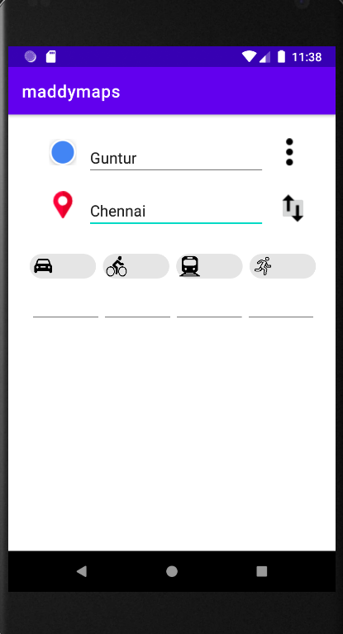 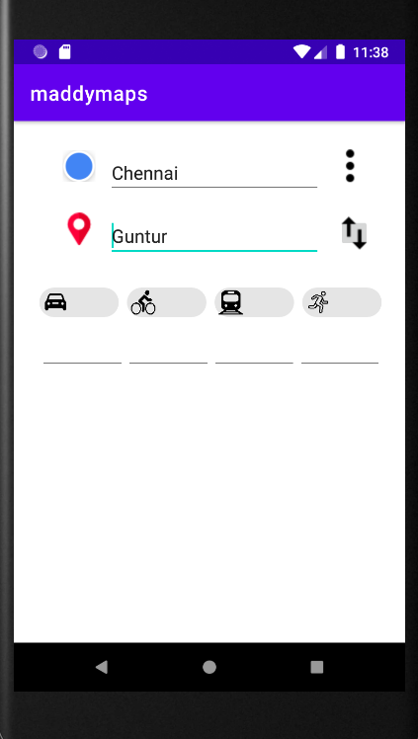 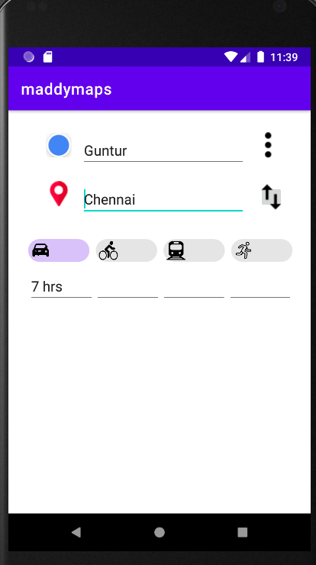 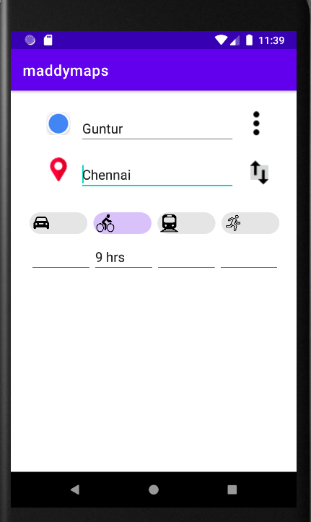 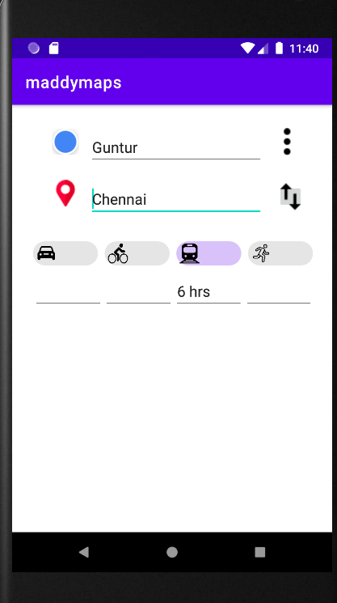 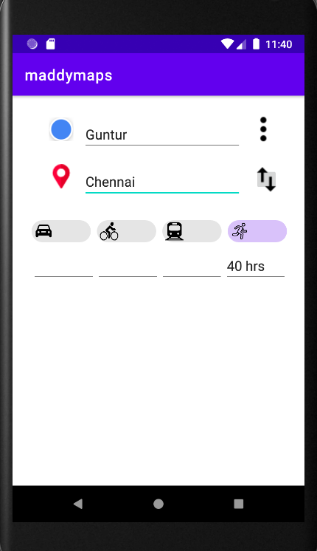

2.Design an App that plans three events by selecting the time form the time picker. On Clicking Submit send the three times to the second Activity and display the event plan. Write Java and XML Code for both the activities.

MainActivity.java

package com.example.eventdetails;  
  
import androidx.appcompat.app.AppCompatActivity;  
  
import android.content.Intent;  
import android.os.Bundle;  
import android.view.View;  
import android.widget.Button;  
import android.widget.EditText;  
import android.widget.TimePicker;  
  
public class MainActivity extends AppCompatActivity {  
 TimePicker timePicker;  
 EditText et1,et2,et3;  
 Button b1,b2,b3,submit;  
  
 @Override  
 protected void onCreate(Bundle savedInstanceState) {  
 super.onCreate(savedInstanceState);  
 setContentView(R.layout.*activity_main*);  
 et1=findViewById(R.id.*et1*);  
 et2=findViewById(R.id.*et2*);  
 et3=findViewById(R.id.*et3*);  
 timePicker=findViewById(R.id.*TimePicker1*);  
 b1=findViewById(R.id.*b1*);  
 b2=findViewById(R.id.*b2*);  
 b3=findViewById(R.id.*b3*);  
 submit=findViewById(R.id.*submit*);  
 b1.setOnClickListener(new View.OnClickListener() {  
 @Override  
 public void onClick(View v) {  
 String currentTime=+timePicker.getCurrentHour()+":"+timePicker.getCurrentMinute();  
 et1.setText(currentTime);  
 }  
 });  
 b2.setOnClickListener(new View.OnClickListener() {  
 @Override  
 public void onClick(View v) {  
 String currentTime=timePicker.getCurrentHour()+":"+timePicker.getCurrentMinute();  
 et2.setText(currentTime);  
 }  
 });  
 b3.setOnClickListener(new View.OnClickListener() {  
 @Override  
 public void onClick(View v) {  
 String currentTime=timePicker.getCurrentHour()+":"+timePicker.getCurrentMinute();  
 et3.setText(currentTime);  
 }  
 });  
 submit.setOnClickListener(new View.OnClickListener() {  
 @Override  
 public void onClick(View v) {  
 Intent i = new Intent(getApplicationContext(),display.class);  
 Bundle bundle = new Bundle();  
 bundle.putString("Event1",et1.getText().toString());  
 bundle.putString("Event2",et2.getText().toString());  
 bundle.putString("Event3",et3.getText().toString());  
 i.putExtras(bundle);  
 startActivity(i);  
 }  
 });  
 }  
}

activity_main.xml

<?xml version="1.0" encoding="utf-8"?>  
<androidx.constraintlayout.widget.ConstraintLayout xmlns:android="http://schemas.android.com/apk/res/android"  
 xmlns:app="http://schemas.android.com/apk/res-auto"  
 xmlns:tools="http://schemas.android.com/tools"  
 android:layout_width="match_parent"  
 android:layout_height="match_parent"  
 tools:context=".MainActivity">  
  
 <Button  
 android:id="@+id/b3"  
 android:layout_width="90dp"  
 android:layout_height="47dp"  
 android:layout_marginStart="24dp"  
 android:layout_marginLeft="24dp"  
 android:text="Set"  
 app:layout_constraintStart_toEndOf="@+id/et3"  
 app:layout_constraintTop_toTopOf="@+id/et3" />  
  
 <EditText  
 android:id="@+id/et3"  
 android:layout_width="126dp"  
 android:layout_height="43dp"  
 android:layout_marginStart="28dp"  
 android:layout_marginLeft="28dp"  
 android:ems="10"  
 android:hint="set time"  
 android:inputType="textPersonName"  
 app:layout_constraintStart_toEndOf="@+id/t3"  
 app:layout_constraintTop_toTopOf="@+id/t3" />  
  
 <TextView  
 android:id="@+id/t3"  
 android:layout_width="wrap_content"  
 android:layout_height="wrap_content"  
 android:layout_marginStart="24dp"  
 android:layout_marginLeft="24dp"  
 android:text="Event3"  
 android:textSize="30sp"  
 app:layout_constraintStart_toStartOf="parent"  
 app:layout_constraintTop_toBottomOf="@+id/t2" />  
  
 <Button  
 android:id="@+id/b2"  
 android:layout_width="90dp"  
 android:layout_height="47dp"  
 android:layout_marginStart="24dp"  
 android:layout_marginLeft="24dp"  
 android:text="Set"  
 app:layout_constraintStart_toEndOf="@+id/et2"  
 app:layout_constraintTop_toTopOf="@+id/et2" />  
  
 <TextView  
 android:id="@+id/t2"  
 android:layout_width="wrap_content"  
 android:layout_height="wrap_content"  
 android:layout_marginStart="24dp"  
 android:layout_marginLeft="24dp"  
 android:text="Event2"  
 android:textSize="30sp"  
 app:layout_constraintStart_toStartOf="parent"  
 app:layout_constraintTop_toBottomOf="@+id/t1" />  
  
 <EditText  
 android:id="@+id/et2"  
 android:layout_width="126dp"  
 android:layout_height="43dp"  
 android:layout_marginStart="28dp"  
 android:layout_marginLeft="28dp"  
 android:ems="10"  
 android:hint="set time"  
 android:inputType="textPersonName"  
 app:layout_constraintStart_toEndOf="@+id/t2"  
 app:layout_constraintTop_toTopOf="@+id/t2" />  
  
 <Button  
 android:id="@+id/b1"  
 android:layout_width="90dp"  
 android:layout_height="47dp"  
 android:layout_marginStart="24dp"  
 android:layout_marginLeft="24dp"  
 android:text="Set"  
 app:layout_constraintStart_toEndOf="@+id/et1"  
 app:layout_constraintTop_toTopOf="@+id/et1" />  
  
 <TimePicker  
 android:id="@+id/TimePicker1"  
 android:layout_width="330dp"  
 android:layout_height="345dp"  
 android:layout_above="@+id/b1"  
 android:layout_centerHorizontal="true"  
 android:layout_marginStart="52dp"  
 android:layout_marginLeft="52dp"  
 android:layout_marginEnd="52dp"  
 android:layout_marginRight="52dp"  
 app:layout_constraintEnd_toEndOf="parent"  
 app:layout_constraintStart_toStartOf="parent"  
 app:layout_constraintTop_toTopOf="parent"  
 tools:ignore="UnknownId" />  
  
 <TextView  
 android:id="@+id/t1"  
 android:layout_width="wrap_content"  
 android:layout_height="wrap_content"  
 android:layout_marginStart="24dp"  
 android:layout_marginLeft="24dp"  
 android:layout_marginTop="10dp"  
 android:text="Event1"  
 android:textSize="30sp"  
 app:layout_constraintStart_toStartOf="parent"  
 app:layout_constraintTop_toBottomOf="@+id/TimePicker1" />  
  
 <EditText  
 android:id="@+id/et1"  
 android:layout_width="126dp"  
 android:layout_height="43dp"  
 android:layout_marginStart="28dp"  
 android:layout_marginLeft="28dp"  
 android:ems="10"  
 android:hint="set time"  
 android:inputType="textPersonName"  
 app:layout_constraintStart_toEndOf="@+id/t1"  
 app:layout_constraintTop_toTopOf="@+id/t1" />  
  
 <Button  
 android:id="@+id/submit"  
 android:layout_width="wrap_content"  
 android:layout_height="wrap_content"  
 android:layout_marginTop="6dp"  
 android:text="submit"  
 app:layout_constraintEnd_toEndOf="parent"  
 app:layout_constraintStart_toStartOf="parent"  
 app:layout_constraintTop_toBottomOf="@+id/et3" />  
</androidx.constraintlayout.widget.ConstraintLayout>

display.java

package com.example.eventdetails;  
  
import androidx.appcompat.app.AppCompatActivity;  
  
import android.content.Intent;  
import android.os.Bundle;  
import android.widget.TextView;  
  
public class display extends AppCompatActivity {  
 TextView t1,t2,t3;  
 @Override  
 protected void onCreate(Bundle savedInstanceState) {  
 super.onCreate(savedInstanceState);  
 setContentView(R.layout.*activity_display*);  
 t1=findViewById(R.id.*textView5*);  
 t2=findViewById(R.id.*textView6*);  
 t3=findViewById(R.id.*textView7*);  
 Intent i = getIntent();  
 Bundle bundle = i.getExtras();  
 t1.setText(bundle.getString("Event1"));  
 t2.setText(bundle.getString("Event2"));  
 t3.setText(bundle.getString("Event3"));  
 }  
}

activity_display.xml

<?xml version="1.0" encoding="utf-8"?>  
<androidx.constraintlayout.widget.ConstraintLayout xmlns:android="http://schemas.android.com/apk/res/android"  
 xmlns:app="http://schemas.android.com/apk/res-auto"  
 xmlns:tools="http://schemas.android.com/tools"  
 android:layout_width="match_parent"  
 android:layout_height="match_parent"  
 tools:context=".display">  
  
 <TextView  
 android:id="@+id/textView7"  
 android:layout_width="wrap_content"  
 android:layout_height="wrap_content"  
 android:layout_marginStart="70dp"  
 android:layout_marginLeft="70dp"  
 android:textSize="30sp"  
 app:layout_constraintStart_toEndOf="@+id/textView4"  
 app:layout_constraintTop_toTopOf="@+id/textView4" />  
  
 <TextView  
 android:id="@+id/textView6"  
 android:layout_width="wrap_content"  
 android:layout_height="wrap_content"  
 android:layout_marginStart="70dp"  
 android:layout_marginLeft="70dp"  
 android:textSize="30sp"  
 app:layout_constraintStart_toEndOf="@+id/textView2"  
 app:layout_constraintTop_toTopOf="@+id/textView2" />  
  
 <TextView  
 android:id="@+id/textView3"  
 android:layout_width="wrap_content"  
 android:layout_height="wrap_content"  
 android:layout_marginStart="68dp"  
 android:layout_marginLeft="68dp"  
 android:layout_marginTop="72dp"  
 android:text="Event 1"  
 android:textSize="30sp"  
 app:layout_constraintStart_toStartOf="parent"  
 app:layout_constraintTop_toBottomOf="@+id/textView" />  
  
 <TextView  
 android:id="@+id/textView4"  
 android:layout_width="wrap_content"  
 android:layout_height="wrap_content"  
 android:layout_marginTop="60dp"  
 android:text="Event 3"  
 android:textSize="30sp"  
 app:layout_constraintStart_toStartOf="@+id/textView2"  
 app:layout_constraintTop_toBottomOf="@+id/textView2" />  
  
 <TextView  
 android:id="@+id/textView"  
 android:layout_width="wrap_content"  
 android:layout_height="wrap_content"  
 android:layout_marginTop="54dp"  
 android:text="Event Details"  
 android:textSize="36sp"  
 app:layout_constraintEnd_toEndOf="parent"  
 app:layout_constraintStart_toStartOf="parent"  
 app:layout_constraintTop_toTopOf="parent" />  
  
 <TextView  
 android:id="@+id/textView2"  
 android:layout_width="wrap_content"  
 android:layout_height="wrap_content"  
 android:layout_marginTop="60dp"  
 android:text="Event 2"  
 android:textSize="30sp"  
 app:layout_constraintStart_toStartOf="@+id/textView3"  
 app:layout_constraintTop_toBottomOf="@+id/textView3" />  
  
 <TextView  
 android:id="@+id/textView5"  
 android:layout_width="wrap_content"  
 android:layout_height="wrap_content"  
 android:layout_marginStart="70dp"  
 android:layout_marginLeft="70dp"  
 android:textSize="30sp"  
 app:layout_constraintStart_toEndOf="@+id/textView3"  
 app:layout_constraintTop_toTopOf="@+id/textView3" />  
</androidx.constraintlayout.widget.ConstraintLayout>

OUTPUT:

